**Federal Contract # DTFH61-17D00001 – Task Order #2**

**LONG-TERM BRIDGE PERFORMANCE PROGRAM**

PROGRESS REPORT NO. 4

Report Period: January 1, 2018 – January 31, 2018

Prepared For:

**Federal Highway Administration**

Prepared By:

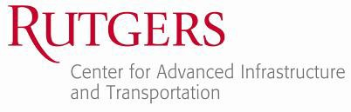

**A. Account of work performed in this period**

* 1. **Coordination and Meetings Between the Contractor and FHWA LTBP Team**

The Rutgers team set up a meeting with FHWA for 2/23. This meeting will be held in TFHRC.

* 1. **Develop LTBP Program bridge performance strategic research matrix**

Work continued on Task 2.2 in January, specifically on the further development of the search and study selection strategies. January’s efforts furthered investigations from December in the three areas previously mentioned: 1) The development of automated scripting tools to utilize literature search web service APIs, 2) A trial literature search for testing the data extraction forms and 3) Continued development of data extraction forms and quality rubrics. These efforts are discussed below in relation to their task numbers:

Task 2.2.3.2: Study Selection Strategy and Task 2.2.3.4: Data Extraction Protocol. Over 500 sources from the Web of Science were reviewed to gain an overview of the depth and breadth of available literature related to the long-term bridge performance program. Keywords from the WoS keyword list were manually extracted from each source. These keywords were then used in the automated search described in the next paragraph.

Task 2.2.3.2: Study Selection Strategy and Task 2.2.3.4: Data Extraction Protocol. Data extraction tables were refined using the test literature search. Automated data extracted scripts using Python were developed. These automated extraction scripts were then used to begin the statistical analysis of the keywords available for a large scale literature review. The code is shown in Appendix A.

Task 2.2.3.2: Study Selection Strategy and Task 2.2.3.4: Data Extraction Protocol. A manual literature search continues to test the study selection, study quality, and study hierarchy checklists.

Task 2.2.3.2: Study Selection Strategy and Task 2.2.3.4: Data Extraction Protocol. A review of topics, organizations, funding agencies, and other meta-data available on the WoS database was conducted. Topics that encompass the search are listed in Appendix B.

Task 2.2.3.2: Study Selection Strategy and Task 2.2.3.4: Data Extraction Protocol. Keywords are currently being sorted under topic headings and grouped for similarity. See Appendix C for a sample of the draft keyword groupings.

Co-PI: 3 hours

Project Engineer: 172.5 hours

Staff Engineer: 88.5 hours

Project Support: 5 hours

* 1. **Conduct training for all field personnel on LTBP Protocols**

No work was performed for this task.

* 1. **Development of data collection protocols and RABIT-CE operations manual**

Task 4.2.1. The Rutgers team received the first draft of the instrumentation protocols (19 in total) from Pennoni on January 23rd. The Rutgers team reviewed and slightly polished the protocols to assure the consistency of the developing protocols. The first drafts of the protocols were submitted to the FHWA on January 25th. Appendix D provides a snapshot of the submitted protocols. By the end of the January 2018, around 60-65% of the entire task was completed.

Task 4.2.2. The regular conference calls have been conducted with the NJIT group to discuss multiple aspects of modifying Bridge Documentation (BD) and Legacy Data Mining (LD) protocols for treated bridge decks. Besides specifying the protocols for treated decks, all the existing protocols (published by FHWA) have been reviewed and multiple corrections have been finalized. The first drafts of the protocols were submitted to the FHWA on January 25th. Appendix E provides a snapshot of the submitted protocols. By the end of the January 2018, unless if the COR’s comments will not be major in the future, around 80-90% of the entire task was completed.

Task 4.2.3. The Rutgers team worked closely with the Infartek to draft the RABIT-CE manual. At the same time, The Rutgers team developed a detailed validation procedure to ensure that the collected NDE data are valid. This validation was embedded in the operations manual which was submitted to the FHWA on January 25th. Appendix F provides a snapshot of the submitted manual. By the end of the January 2018, around 60-70% of the entire task was completed.

Co-PI: 3 hours

Staff Engineer: 192 hours

Project Support: 19 hours

* 1. **Legacy Data Mining data extraction**

The following tasks were accomplished for the month of January:

* Data extraction were performed throughout the month for the bridge plans provided. It should be noted that these data extraction being performed by everyone in the LDM group will take up the majority of the groups effort to complete.
* Work has begun extracting and preparing the BLOB (Binary Large Object) files for implementation into Bridge Portal. The detailed BLOB implementation plan has been included in the appendix G.
* Quality control and quality assurance was provided for the data extraction performed this month and last month by reviewing the data collected by the students on the data extraction excel input sheet. (A more detailed breakdown of how quality control and quality assurance of the data is being provided is included in the Quality Management Plan found in the appendix H)
* Continued to periodically work on updating and improving the excel input sheet for data extraction to ensure that all of the data being collected and included in the sheet is uniform as well as accurate.
* Worked on further updating all bridge structure numbers to exactly match NBI structure numbers for a smoother future upload to Bridge Portal (e.g. no leading zero’s can be missing for any structure number).
* Developed a list of potential issues with certain LDM technical fields that data extraction is being performed on as well as recommended solutions to fix them. This list will be included in future recommended changes to LDM protocols.

CO-PI: 4 hours

Staff Engineer: 153.00 hours

Technician: 121.00 hours

Project Support: 18 hours

* 1. **Organize, conduct, and participate in LTBP workshops and meetings**

During this period, the Bridge Intelligence team replied to FHWA’s requests regarding TRB 2018 meeting. The detail is in the subcontract section.

CO-PI: 9.5 hours

* 1. **Publications, website, communications, and technical assistance**

The Rutgers team prepared the electronic version of the monthly progress report and submitted it to FHWA. Moreover, the Rutgers team developed a MS Project file showing the project milestone and submitted it to FHWA.

Moreover, the Bridge Intelligence team replied to numerous FHWA’s requests. The detail is in the subcontract section.

Co-PI: 59.50 (For December 2017 and January 2018)

Project Support: 20 hours

**B. Work to be accomplished during the next period**

* 1. **Coordination and Meetings Between the Contractor and FHWA LTBP Team**

The Rutgers team will attend the 2/23 meeting at TFHRC and will submit the meeting minutes to FHWA afterwards.

* 1. **Develop LTBP Program bridge performance strategic research matrix**

The Rutgers team will continue the statistical analysis of keywords, finalizing the scripting to extract meta-data for the literature review, and finishing the manual search for validation of the search process. Work will begin on the format for the SRM visualization.

* 1. **Conduct training for all field personnel on LTBP Protocols**

No work is planned under this task for the next reporting period.

* 1. **Development of data collection protocols and RABIT-CE operations manual**

Task 4.2.1 - The Rutgers team is carefully reviewing the instrumentation protocols and developing a list of problematic issues. There are several fields which are required to be developed in more details. Some parts of the issues will be referred to Pennoni and the remaining parts will be addressed by The Rutgers team.

Task 4.2.2 - The Rutgers team is developing a brief report to demonstrate the current status of protocols’ fields in terms of their availability from the bridge documents. The result of this report will be presented during the COR-Rutgers meeting on Feb 23rd.

Task 4.2.3 - As soon as COR returns their comments, The Rutgers team will implement and finalize those on the final draft.

* 1. **Legacy Data Mining data extraction**

The Rutgers team will continue with the data extraction from bridge documentations for the bridges that are assigned by FHWA. In addition, the team will perform QA/QC to make sure that the content being recorded in the main excel file is of high quality. The team will continue to update the main excel sheet with minor improvements in order to increase efficiency.

* 1. **Organize, conduct, and participate in LTBP workshops and meetings**

No work is planned under this task for the next reporting period.

* 1. **Publications, website, communications, and technical assistance**

The Rutgers team will prepare the electronic version of the monthly progress report and will submit it to FHWA. Moreover, the Rutgers team will submit the updated MS Project file to FHWA. No work is planned related to the publications, website, or technical assistance portion of this task.

**C. Problems/Recommended Solutions**

No problems encountered during this period.

**D. How the results of the work performed supports one or more of the FHWA, DOT and LTBP Goals**

The following is a summary of how the work performed on the primary tasks of this task order contribute to meeting the FHWA, DOT, and LTBP program goals.

**Task 2 - Develop LTBP Program bridge performance strategic research matrix**

Fundamentally, the SRMs aim to link the LTBP program to the larger research community. By placing the LTBP efforts in this larger context, the program will be able to identify potential synergies and collaborative opportunities as well as any overlaps that may exist. This will both increase the cost effectiveness of the program as well as the program’s impact on bridge engineering practice through clearly showing how the LTBP program contributes to the overall bridge performance research landscape.

**Task 3 - Conduct training for all field personnel on LTBP Protocols**

At the heart of the LTBP program’s data collection effort is the requirement that data be obtained in a consistent and reliable manner across the breadth of the program. Variations in collection techniques or unreliable practices would pollute the data streams and greatly limit the ability of the program to meets its goal of improving our understanding of long-term bridge performance. Activities under this task aim to ensure that the data collection efforts of the LTBP program are executed by teams with the required expertise to obtain consistent and reliable data.

**Task 4 - Development of data collection protocols and RABIT-CE operations manual**

Similar to the training work being conducted under Task 3, this task is also involved in ensuring consistent and reliable data collection throughout the program. Specifically, this task will develop additional protocols and operations manuals that specify best-practice approaches for data collection.

**Task 5 - Legacy Data Mining data extraction**

In addition to ensuring consistent and reliable data collection efforts, the overarching goal of the program is also dependent upon the completeness of the data collection efforts. This task contributes to this through the collection of available legacy data. This data not only provides a means to ensure field data collection efforts are carried out efficiently (i.e. on bridges best suited to meeting the program’s goals) but also provides context to the data to help explain observed trends and correlations (and thus further our understanding of long-term bridge performance).

**E. Purchases and Rentals**

Nothing was purchased during this period.

**F. Travel Details for Reporting Period**

No travel occurred during this reporting period.

**G. Current and Cumulative Expenditures (cost shown includes benefits and overhead)**

|  |  |  |
| --- | --- | --- |
| **Institution** | **Current Expenditures**  **12/1/2017 – 12/31/2017** | **Cumulative Expenditures**  **10/1/2017 – 12/31/2017** |
| Rutgers, the State University of New Jersey | $ 71,069.00 | $ 152,624.00 |
| Bridge Intelligence LLC | $ 11,365.49 | $ 11,365.49 |

**H. Subcontractor’s Progress Report**

**Sub-recipient Name:** Bridge Intelligence LLC

**Subaward No:** 00000286

**Principal Investigator:** Hooman Parvardeh

**LTBP TSSC**

**Federal Contract # DTFH61-17-D00001**

PROGRESS REPORT NO. 1

For the Period from 12/1/2017 through 1/31/2018

1. Accomplishments/Work Performed

The following is a complete account of all accomplishments and work performed on each task during this reporting period.

Task 1: (Coordination and Meetings between the Rutgers and FHWA LTBP Team)

Nothing was done under this task during this period.

This task is approximately 5% complete.

Task 2: (Develop LTBP Program Bridge Performance Strategic Research Matrix)

During this period, Mr. Parvardeh reviewed the overall scope of the task as required by FHWA. Moreover, he reviewed the monthly progress of the task for October and December.

Number of hours during this period: 3 hours

This task is approximately 4% complete.

Task 3: (Conduct Training on Proper Use and Application of LTBP Field Assessment Protocols)

During this period, Mr. Parvardeh reviewed the overall scope of the task as required by FHWA. He reviewed all the previously developed material on LTBP Protocol training and updated the curriculum based on the new set of protocols published by FHWA.

Number of hours during this period: 10.5 hours

This task is approximately 12% complete.

Task 4: (Development and Refinement of Data Collection Protocols)

During this period, Mr. Parvardeh worked with Dr. BabaNejad on the development of the treated bridge decks data collection protocols.

Number of hours during this period: 3 hours

This task is approximately 15% complete.

Task 5: (Legacy Data Mining Data Extraction and Upload)

During this period, the Bridge Intelligence team worked with the Rutgers team to update the excel file based on the new protocols.

Number of hours during this period: 4 hours

This task is approximately 5% complete.

Task 6: (Organize, Conduct, and Participate in LTBP Workshops and Meetings)

During this period, the Bridge Intelligence team performed the following tasks:

* Fixed the issue with Rutgers LTBP6 server for the TRB 2018 conference. On January 4th, FHWA informed us that the server is not working and it should work for the TRB 2018 booth show. We ran many software and hardware diagnostics and discovered that the switch which was connected to the server was broken. We purchased a new similar switch and replaced it with the old switch. Afterwards, we reconfigured the network to work with the new switch and fixed the issue.
* Help the LTBP TRB team with a few issues that they were facing in the LTBP 2018 TRB booth regarding the network connection and LTBP Bridge Portal.

Number of hours during this period: 9.5 hours  
Cost of the Netgear switch: $88.49

This task is approximately 8% complete.

Task 7: (Publication, Website, Communication, and Technical Assistance)

During this period, the Bridge Intelligence team performed the following tasks:

During this period, Mr. Parvardeh performed the following tasks:

* Modified the MS Project to be ready for monthly progress submittal
* Prepared and submitted monthly progress report for November including updated MS project
* Prepared and submitted monthly progress report for December including updated MS project
* Prepared for and attended a meeting at Infratek regarding data upload into Bridge Portal – Requested by FHWA and Pennoni (12/1/2017)
* Prepared for and Participated in a conference call regarding data upload into Bridge Portal – Requested by FHWA and Pennoni (1/31/2018)
* Prepared for and participated in a conference call regarding Bridge Portal migration to cloud – Requested by FHWA (12/12/2017)
* Prepared for and participated in a meeting regarding Bridge Portal migration to cloud at the 2018 TRB– Requested by FHWA (1/9/2018)
* Prepare for and participated in a conference call regarding Bridge Portal migration to cloud – requested by Rutgers (1/30/2018)
* Preparation of the Bridge Portal source code, Database, and copying them on an external hard drive. Shipping the hard drive to FHWA
* Copying the Bridge Portal source code on the Google cloud and providing FHWA with the link to access the source code
* Preparation of documents for LTPP team for migration of Bridge Portal to the cloud (user access document and modification of the LTBP user requirement document)

Number of hours during this period: 59.5 hours

This task is approximately 15% complete.

1. Work Anticipated During the Next Period

For the next period, the Bridge Intelligence team will work with the Rutgers team to satisfy the FHWA requirements.

1. Changes /Problems

None.

1. Participants & charged Level of Efforts

|  |  |  |  |
| --- | --- | --- | --- |
| **Personnel Name** | **Role/Contribution** | **Total Hours** | **Billed Cost** |
| Hooman Parvardeh | Principal | 89.5 | $ 11,277.00 |

Additionally, there is an $88.49 charge for the cost of Netgear switch.

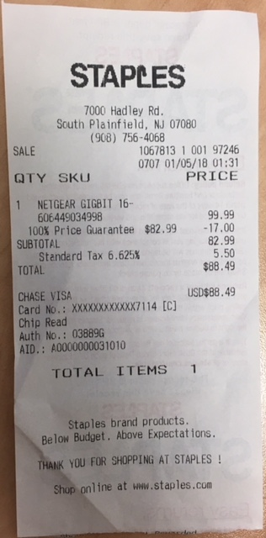

1. Travel

None.

**I. Appendices  
  
Appendix A**

#### Summary

This code takes a list of keywords from an external file and counts their usage over a list of resources returned for a fixed set of keywords by the Web of Science.

Example: Given the fixed set {'concrete', 'deck'}, find the number of times each of {'chloride','aggregate', 'adhesion', 'freeze thaw'} are used in the title, abstract, and keyword lists for the total list of sources returned for the fixed set.

Example Return: Chloride: Title - 10, Abstract - 20, Keywords - 15, Keywords Plus - 2

#### Check for Being on Rutgers Network

import socket

s = socket.socket(socket.AF_INET, socket.SOCK_DGRAM);

s.connect(("www.google.com",80));

myAddress = (s.getsockname()[0]);

s.close();

name, other, ip = socket.gethostbyaddr(myAddress);

'rutgers' in name

True

#### Check Connection to WoS

from wos import WosClient

import wos.utils

checkClient = WosClient()

checkClient.connect()

Authenticated (SID: 7F64SyB4eOsqgvnokPc)

'7F64SyB4eOsqgvnokPc'

checkClient.close()

#### User Input

keywordsLock = [['concrete'],

['bridge'],

['concrete', 'deck'],

['bridge', 'deck'],

['concrete', 'bridge', 'deck']];

maxCount = 5; # maximum number of results to be queried at a time...

# WoS returns a string with XML headers and info where

# each result is concatenated to the previous

keywordsListFile = './KeywordsToSearch.xls'

#### Input external Keywords File

import pandas as pd

keyFrame = pd.read_excel(keywordsListFile, sheetname=1, header=None, index_col=None)

keyList = keyFrame.iloc[:,0].tolist();

#### Get number of results for each query

try:

if 'searchClient' in locals():

searchClient.close()

searchClient.connect()

else:

searchClient = WosClient()

searchClient.connect()

except:

searchClient = WosClient()

searchClient.connect()

Authenticated (SID: 8ClRSZPpltAAGhJxWcr)

#### Search for Terms

space = ' AND '

searchResult = []

subject = ' AND WC=("Engineering, Civil" OR "Construction & Building Technology")'

for num, keywords in enumerate(keyList):

if num > 1000:

try:

if 'searchClient' in locals():

searchClient.close()

searchClient.connect()

else:

searchClient = WosClient()

searchClient.connect()

except:

searchClient = WosClient()

searchClient.connect()

for lockwords in keywordsLock:

query = 'TS = (' + space.join(lockwords) + space + \

space.join(keywords.split(' ')) + ')' + subject

# search client takes args: query, count, offset (start), max

# count = 0 returns number of results without metadata

response = searchClient.search(query,0)

searchResult.append([response.recordsFound, keywords, lockwords])

#### Convert to Pandas DataFrame

labels = ['record_count','keywords','locked_keywords']

df = pd.DataFrame.from_records(searchResult,columns=labels)

df.head()

|  | record_count | keywords | locked_keywords |
| --- | --- | --- | --- |
| 0 | 179 | 3D imaging | [concrete] |
| 1 | 57 | 3D imaging | [bridge] |
| 2 | 5 | 3D imaging | [concrete, deck] |
| 3 | 6 | 3D imaging | [bridge, deck] |
| 4 | 5 | 3D imaging | [concrete, bridge, deck] |

import xlswt

writer = pd.ExcelWriter(keywordsListFile)

for num,lockwords in enumerate(keywordsLock):

sortedResults = df.loc[df['locked_keywords'].apply(lambda x:x==lockwords),['keywords','record_count']];

sortlist = pd.DataFrame(sortedResults.sort_values('record_count',ascending=False))

print(num)

# write list to excel

sortlist.to_excel(writer, sheet_name='sorted_keywords_count', \

startcol=2*num,startrow = 2,index=False)

# add lockwords to 2nd row

# do this here

writer.save()

**Appendix B**

Category Name Construction & Building Technology  
Category Description  
Construction & Building Technology includes resources that provide information on the physical features and design of structures (e.g., buildings, dams, bridges, tunnels) and the materials used to construct them (concrete, cement, steel). Other topics covered in this category include heating and air conditioning, energy systems, and indoor air quality.

Category Name Engineering, Civil  
Category Description  
Engineering, Civil includes resources on the planning, design, construction, and maintenance of fixed structures and ground facilities for industry, occupancy, transportation, use and control of water, and harbor facilities. Resources also may cover the sub-fields of structural engineering, geotechnics, earthquake engineering, ocean engineering, water resources and supply, marine engineering, transportation engineering, and municipal engineering.

Category Name Green & Sustainable Science & Technology  
Category Description  
This category covers resources that focus on basic and applied research on green and sustainable science and technology, including green chemistry; green nanotechnology; green building; renewable and green materials; sustainable processing and engineering; sustainable policy, management and development; environmental and agricultural sustainability; renewable and sustainable energy; and innovative technologies that reduce or eliminate damage to health and the environment.

Category Name Imaging Science & Photographic Technology  
Category Description  
Imaging Science & Photographic Technology includes resources that cover pattern recognition, analog and digital signal processing, remote sensing, and optical technology. This category also covers resources on the photographic process (the engineering of photographic devices and the chemistry of photography) as well as machine-aided imaging, recording materials and media, and visual communication and image representation.

Category Name Instruments & Instrumentation  
Category Description  
Instruments & Instrumentation includes resources on the application of instruments for observation, measurement, or control of physical and/or chemical systems. This category also includes materials on the development and manufacture of instruments.

Category Name Materials Science, Characterization & Testing  
Category Description  
Materials Science, Characterization & Testing covers resources that focus on techniques used to evaluate and test materials. These techniques include nondestructive testing, diffraction analysis, electron microscopy, electron spectroscopy, ion beam analysis, mechanical testing, optical characterization, and scanning tunneling microscopy.

Category Name Materials Science, Multidisciplinary  
Category Description  
Materials Science, Multidisciplinary covers resources having a general or multidisciplinary approach to the study of the nature, behavior, and use of materials. Relevant topics include ceramics, composites, alloys, metals and metallurgy, nanotechnology, nuclear materials, and adhesion and adhesives.

Category Name Transportation Science & Technology  
**Category Description**  
Transportation Science & Technology covers resources on all aspects of the movement of goods and peoples as well as the design and maintenance of transportation systems. Topics covered in this category include logistics, vehicular design and technology, and transportation science and technology. Note: Resources that concentrate on transportation safety, policy, economics, and planning appear under the TRANSPORTATION category in the SSCI.

**Appendix C**



**Appendix D. Samples of the instrumentation protocols**

Overview of the Instrumentation Protocols

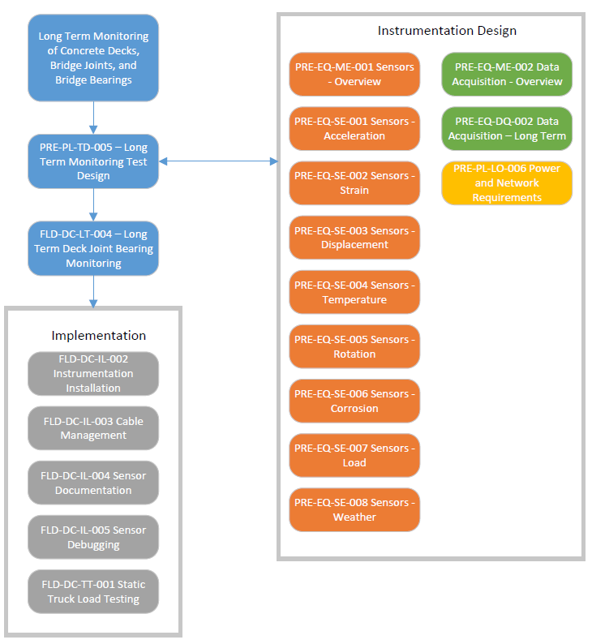

Sample Protocol for Acceleration Sensor

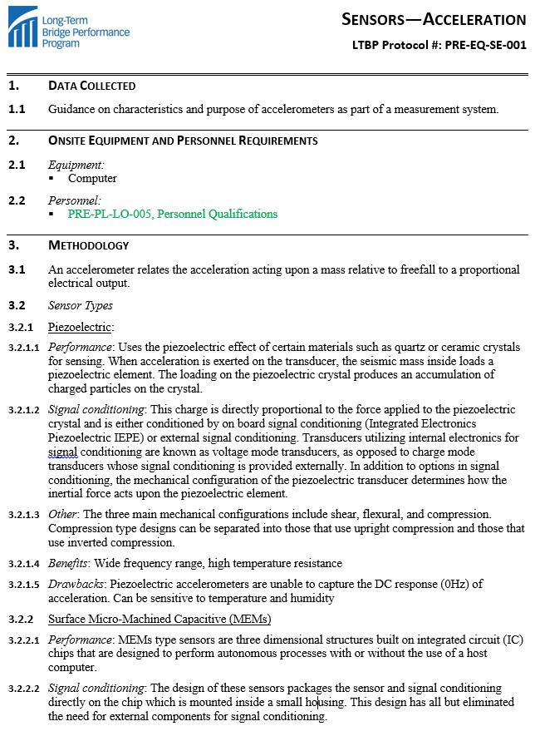

**Appendix E. Samples of the protocols developed for treated bridge decks**

Sample Protocol for Bridge Documentation

| # | Field Name | Data Type | Accuracy | Unit | Field Description |
| --- | --- | --- | --- | --- | --- |
| **General Overlay Details** | | | | | |
| **T115.1** | Wearing surface type (overlay) | Predefined list |  |  | If applicable,  Monolithic concrete (concurrently placed with structural deck)  Integral concrete (separate non-modified layer of concrete added to structural deck)  Latex concrete or similar  additive  High performance concrete overlays (rigid)  Low slump concrete  Epoxy overlay  Bituminous  None |
| **T115.2** | Wearing surface, date of application | Text |  | Month and year | mm/yyyy, if applicable |
| **T115.3** | AASHTO overlay specification | Text |  |  |  |
| **T115.4** | State overlay specifications | Text |  |  | Document name |
| **T115.5** | Wearing surface thickness | Number | 0.25 | in. | If applicable |
| **T115.6** | Overlay bonding | Predefined list |  |  | Unbonded, bonded, partially bonded, unknown |
| **T115.7** | Adhesive type between overlay and original deck | Text |  |  | Binder name |
| **T115.8** | Water proofing membrane type | Predefined list |  |  | Formed sheets, liquid membrane, built-up, none |
| **T115.9** | AASHTO membrane specification | Text |  |  |  |
| **T115.10** | State membrane specifications | Text |  |  | Document name |
| **T115.11** | Water proofing membrane manufacture | Text |  |  |  |
| **T115.12** | Water proofing membrane thickness | Number | 0.1 | in. |  |
| **T115.13** | Comments | Text |  |  |  |
| **Cement-based Overlay Details** | | | | | |
| **T115.14** | Concrete type | Predefined list |  |  | Latex modified cement, pozzolan-modified concrete, polymer concrete, cement epoxy |
| **T115.15** | Cement type | Predefined list |  |  | I, II, III, IV, or V |
| **T115.16** | Cement quantity | Number | 1 | lb/yd3 | Amount from mix design |
| **T115.17** | Fly ash type | Predefined list |  |  | Type C or Type F |
| **T115.18** | Fly ash quantity | Number | 1 | lb/yd3 | Amount from mix design |

Sample Parts of the Legacy Data Mining Protocol for Treated Bridge Decks

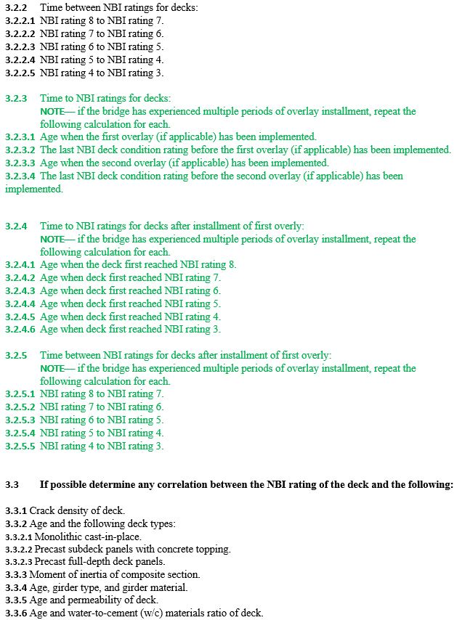

**Appendix F. Sample standards embedded in the proposed RABIT-CE operations manual**

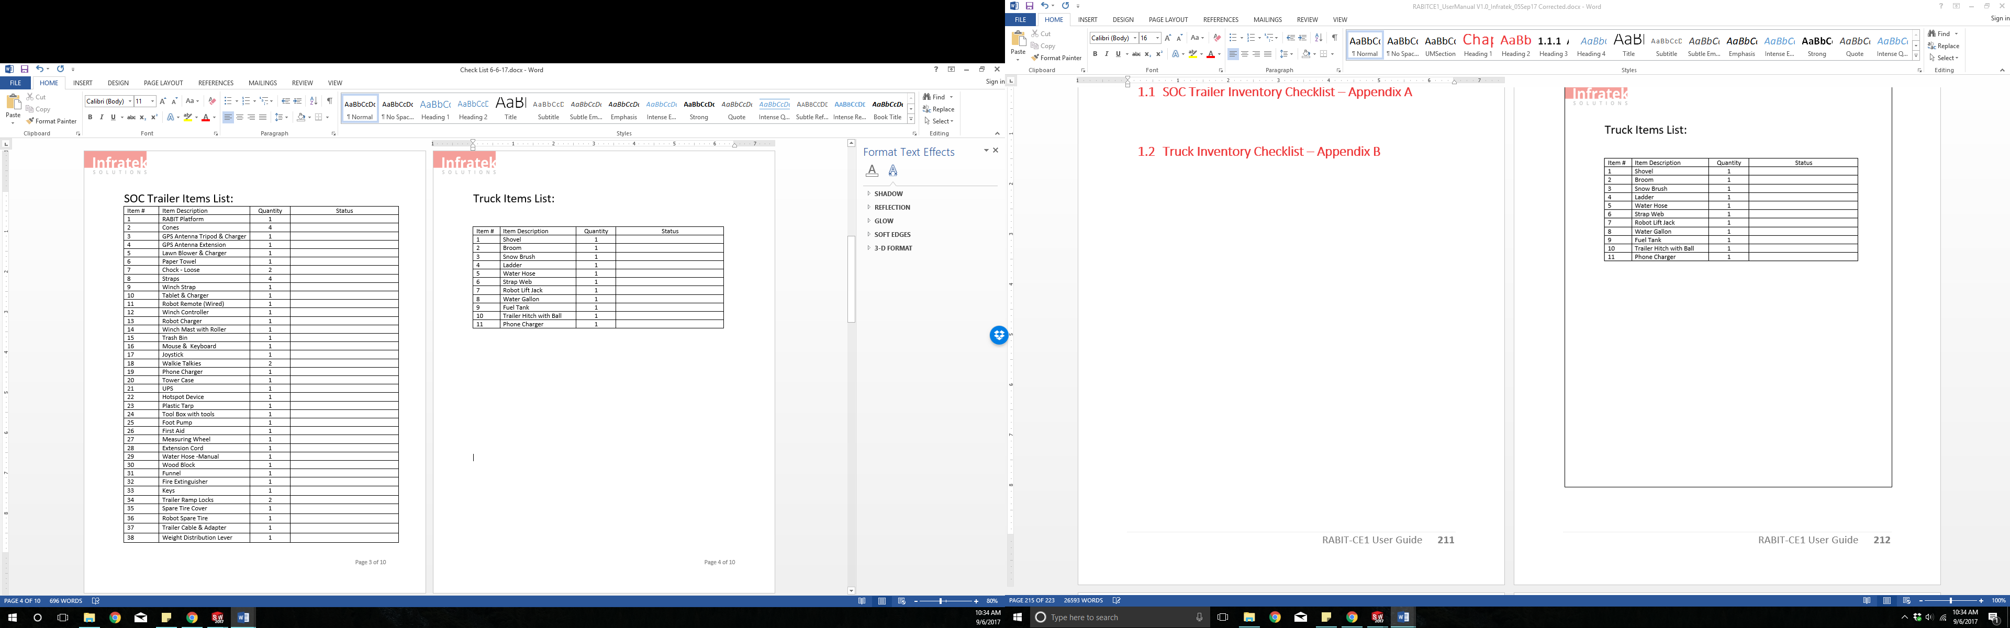

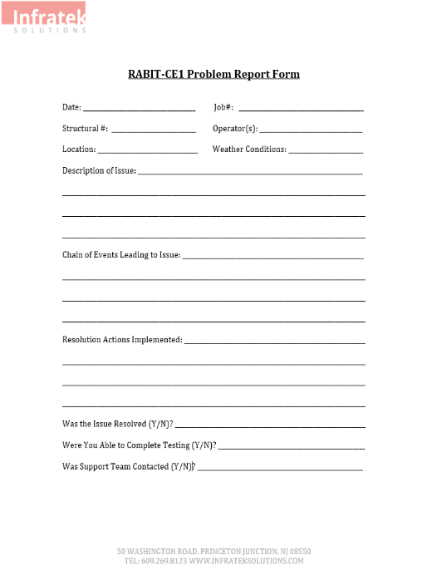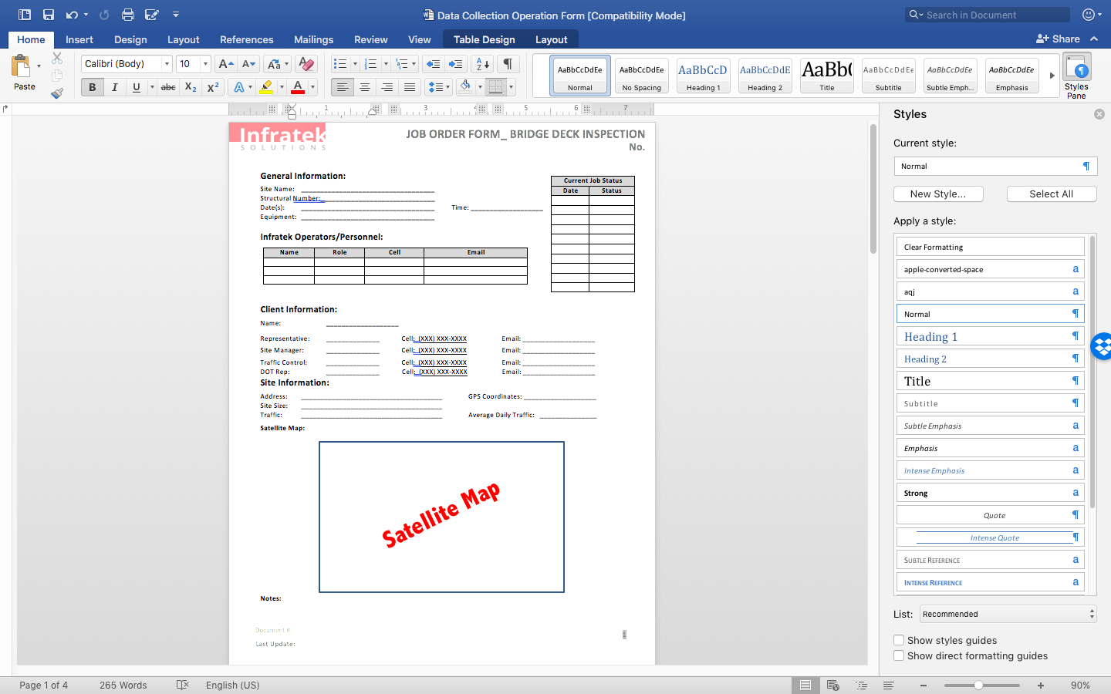

**Appendix G. BLOB File Implementation Plan**

|  |  |  |  |  |  |  |  |
| --- | --- | --- | --- | --- | --- | --- | --- |
| BLOB File Implementation Plan | | | | | | | |
| **Item #** | **Proto. #** | **Field Name** | **Do we have for each bridge?** | **File Type** | **File Name** | **File Name (full)** | **Suggestions** |
| 1 | 24 | Original bridge design plans | yes (one or the other) | .pdf | OP | OP.pdf | There is usually only one set of plans per bridge, original or as-built |
| 2 | 25 | Shop drawings | some | .pdf | SH | SH.pdf |  |
| 3 | 26 | As-built plans | yes (one or the other) | .pdf | AP | AP.pdf | There is usually only one set of plans per bridge |
| 4 | 27 | State design specifications | not included | .pdf | DS | DS.pdf | Do not add this for every bridge, just reference the spec and then have a separate page with all of the different state specs on it |
| 5 | 28 | State materials specifications | not included | .pdf | MS | MS.pdf | Do not add this for every bridge, just reference the spec and then have a separate page with all of the different state specs on it |
| 6 | 29 | State construction specifications | not included | .pdf | CS | CS.pdf | Do not add this for every bridge, just reference the spec and then have a separate page with all of the different state specs on it |
| 7 | 30 | Special provisions for the design or construction of the bridge | rare | .pdf | SP | SP.pdf |  |
| 8 | 31 | Foundation design report | some | .pdf | FR | FR.pdf |  |
| 9 | 32 | Soils report | some | .pdf | SR | SR.pdf |  |
| 10 | 207 | Location of tendons in pretensioned concrete girder cross-section (Elevation) | yes | .jpg | EL | EL.JPG |  |
| 11 |  | Location of tendons in pretensioned concrete girder cross-section (Cross-section) | yes | .jpg | CS | CS.JPG |  |
| 12 | 220 | Location of tendons in posttensioned concrete girdercross-section (Elevation) | yes | .jpg | EL | EL.JPG |  |
| 13 |  | Location of tendons in posttensioned concrete girdercross-section (Cross-section) | yes | .jpg | CS | CS.JPG |  |
|  |  |  |  |  |  |  |  |

Notes

* Structure number on the file folder needs to perfectly match the Structure number form the excel sheet
* All Structure numbers need to be updated on our list of bridges first (we can update the PSI file directly if needed)
* All file names need to be uppercase (e.g. OP.pdf)
* All files .jpg files need to be capitalized (e.g. ".JPG" not ".jpg")
* In the main excel sheet make sure that for each BLOB column there is either a "yes" or a "no" checked off for their corresponding cell

**Appendix H. LDM Quality Management Plan**

Last updated 2018-02-14

**Project Background:**

*The project goal is to collect as much bridge data as quickly and with as few data input errors as possible while also keeping the data as accurate as can be. This document will aim to correct many of the issues that we have had in previous Legacy Data Mining data collection efforts in the past, and are all addressed below.*

**Goals for Project Metrics:**

|  |  |  |  |
| --- | --- | --- | --- |
| **Metric** | **Goal** | **Rationale** | **How we’ll do it** |
|  |  |  |  |
| Quantitative Data Practical Ranges | Reducing all erratic data that is very obviously incorrect to 0% or as close to 0% as possible. | Some extracted data may be recorded completed wrong (e.g. decimal in the wrong place, ft instead of in). This widely incorrect data will heavily skew any statistical data being taken and needs to be eliminated as best as possible. | By reviewing any outliers from each quantitative column that do not fall within a certain acceptable practical threshold. |
| Perform Statistical Sampling of Extracted Bridge Data | Thorough review of 5% of the bridges that data extraction has already been performed on in order to have a better idea where the trouble data is. | This will give us a better idea of how many errors we are receiving and which fields are producing the majority of these errors. | A thorough review will be done randomly on 5% of the bridges being collected. All errors found on these bridges being reviewed will be recorded on a separate excel sheet for further analysis as to why the error occurred in the first place. |
| Improved Training Methods | To ensure that new team members have the best possible training and knowledge on how to perform the data extraction being done accurately and efficiently. | A lot of time and energy can be saved fixing and editing collected bridge data if the team members collecting the data are properly trained in the data extraction in the first place. | On top of the NHI training course already provided to the group, and detailed guide will be produced and distributed to new team members which will give a detailed description of each field and how to record the data for that field properly. |
| Preventative Action to Eliminate Errors | Implement various methods that will reduce any input errors to the data extraction sheet before they even occur. | Much time will be saved reviewing and fixing extracted bridge data if certain measures are taken beforehand to prevent these errors from occurring in the first place. | This will be a multi-step process used to prevent errors in data collection. A detailed error prevention plan is outlined later in this document. |
| Updates to Data Input | Increasing the efficiency and accuracy of which data is being inputted into the data extraction excel sheet by improving the quality of the input excel sheet itself. | Creating more efficient input methods for team members to perform their data extraction will allow for the extraction to be done more quickly and with less errors. This input sheet should be updated periodically in order to ensure it is working as efficiently as possible to reduce errors and proved quality data | The main data extraction excel sheet will be reviewed on a weekly basis based off of new data being added to the sheet as well as any errors found in the statistical sampling in order to continuously improve our data collection efforts. |

**Error Prevention Plan:**

*In order to prevent incorrect data recorded to the data input excel sheet, the following measures will be implemented:*

* Reduction of total personnel performing the data extraction in order to reduce variance in the data collected from bridge plans.
* Restricted user input for the cells on certain fields on the data input excel sheet in order to prevent incorrect or improperly formatted data in the sheet.
* All data collection is being performed within one group (Rutgers University LTBP) which will drastically help in reducing any variation within data collection, as well as ensuring that all QA/QC guidelines are being followed.
* Training methods have been improved to include a more detailed description of how to record the data properly for each field through the creation of our LDM data extraction guide.